Trial Installation Notes (.NET)

- Download
Download the installer from http://www.easyxls.com/trials

- Run
Double-click on “EasyXLS_Trial_for_DotNet.exe” to run the installer

- Welcome
The installer will display the Welcome screen.
Press the Next button to continue the installing process.

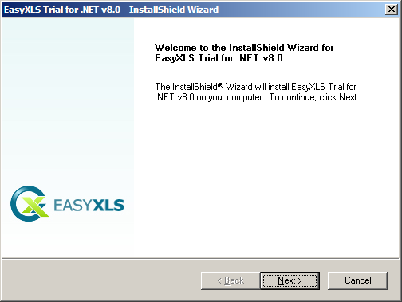

- License agreement
Read the license agreement carefully. Select “I accept the terms of the license agreement” radio button if you agree with it.
Press Next button.

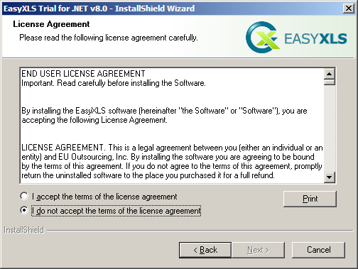

- Register
Enter personal information:
  - User Name: your name
  - Company Name: your company name
Press Next button.

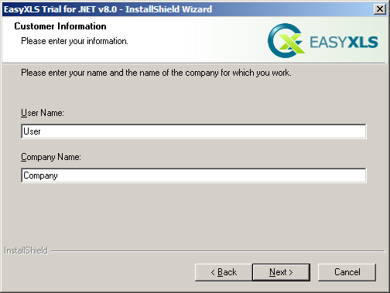

- Certify
Enter the requested information to certify yourself:
  - Certified Name: your name
  - Email: your email
  - Select the checkbox if you want to receive information on EasyXLS software products
Press Next button.

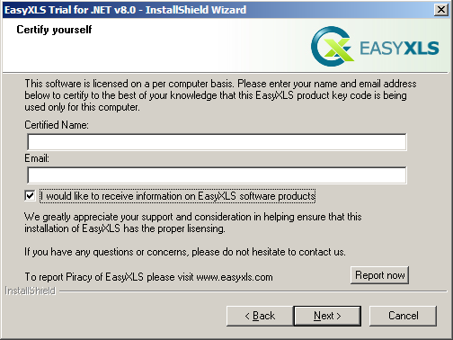

- Setup Type
Select the setup type that best suits you:
  - Complete: .NET DLL, COM DLL, API Documentation and Tutorials will be installed. Go to Step 9 (Ready install).
  - Custom: if you want to select the features to be installed
  - Destination folder: click Browse… to select the destination folder.
Press Next button.

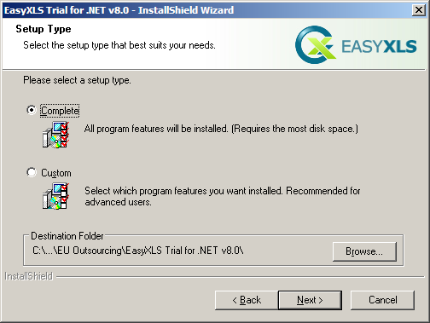

- Select features
Select the features you want to install and deselect the features you don’t want to install.
Press Next button.

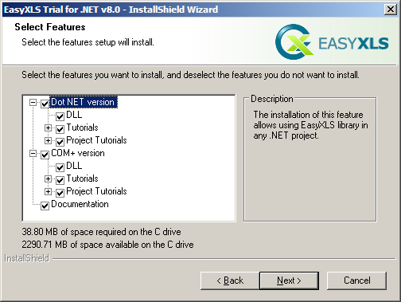

- Ready install
EasyXLS is ready to be installed.
Press Install button.

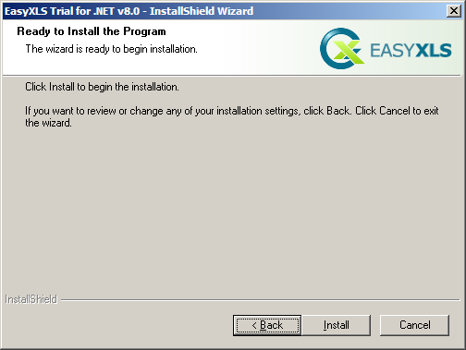

- Installation
Please wait to complete the installation.

- Finish
The installation is completed.
Press Finish button.

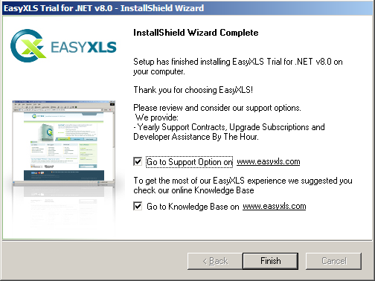

- Read me
ReadMe.txt is displayed. The file contains your trial license key and a license agreement.

